**LAB 3**

**Creation of Company Database**

1. create database company_221b056;
2. use Company_221b056;
3. create table EMPLOYEE (Fname varchar(20) not null, Minit char(1) not null, Lname

varchar(20) not null, Ssn int not null, Bdate date not null, Address varchar(50) not null, Sex char(1) not null, Salary double not null, Super_ssn varchar(10), Dno int not null);

insert into EMPLOYEE values

('John','B','Smith',123456789,'1965-01-09','731 Fondren,

Houston, TX','M',30000,'333445555',5),

('Franklin','T','Wong',333445555,'1955-12-08','638 Voss,

Houston, TX','M',40000,'888665555',5),

('Alicia','J','Zelaya',999887777,'1968-01-19','3321 Castle,

Spring, TX','F',25000,'987654321',4),

('Jennifer','S','Wallace',987654321,'1941-06-20','291 Berry,Bellaire, TX','F',43000,'888665555',4),

('Ramesh','K','Narayan',666884444,'1962-09-15','975 Fire

Oak, Humble, TX','M',38000,'333445555',5),

('Joyce','A','English',453453453,'1972-07-31','5631

Rice, Houston, TX','F',25000,'333445555',5),

('Ahmad','V','Jabbar',987987987,'1969-03-29','980

Dallas, Houston, TX','M',25000,'987654321',4),

('James','E','Borg',888665555,'1937-11-10','450

Stone, Houston, TX','M',55000,'NULL',1);

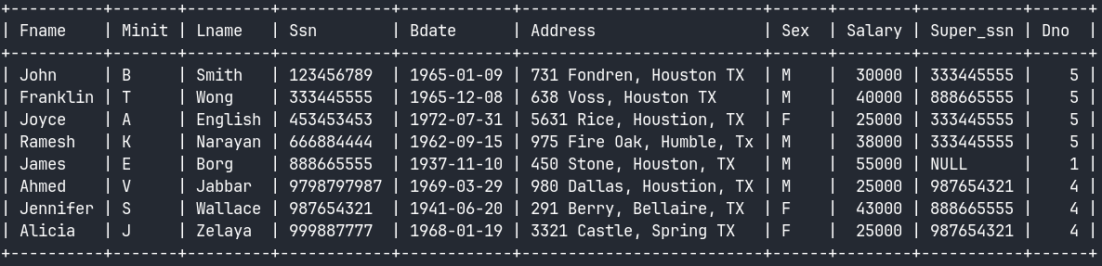

1. create table DEPARTMENT (Dname varchar(20) not null, Dnumber int not null, Mgr_ssn int not null, Mgr_start_date date not null);

insert into DEPARTMENT values

('Research',5,333445555,'1988-05-22'),

('Administration',4,987654321,'1995-01-01'),

('Headquarters',1,888665555,'1981-06-19');

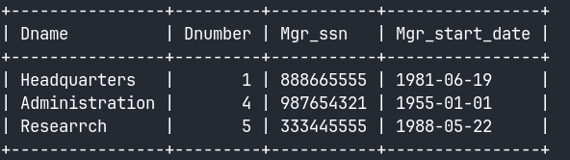

1. create table DEPT_LOCATIONS (Dnumber int not null, Dlocation varchar(20) not null);

insert into DEPT_LOCATIONS values

(1,'Houston'),(4,'Stafford'),(5,'Bellarie'),(5,'Sugarland'),(5,'Houston');

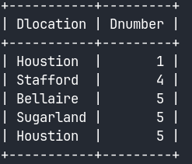

1. create table WORKS_ON (Essn int not null,Pno int not null,Hours varchar(10));

insert into WORKS_ON values

(123456789,1,32.5),(123456789,2,7.5),(666884444,3,40.0),(453453453,1,20.0),

(453453453,2,20.0),(333445555,2,10.0),(333445555,3,10.0),(333445555,10,10.0),

(333445555,20,10.0),(999887777,30,30.0),(999887777,10,10.0),(987987987,10,35.0),

(987987987,30,5.0),(987654321,30,20.0),(987654321,20,15.0),(888665555,20,'NULL');

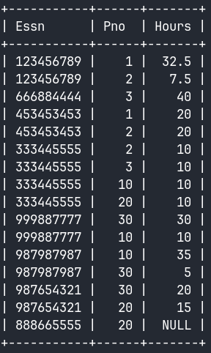

1. create table PROJECT (Pname varchar(20) not null, Pnumber int not null,Plocation

varchar(25) not null,Dnum int not null);

Insert into PROJECTvalues

('ProductX',1,'Bellarie',5), ('ProductY',2,'Sugarland',5),

('ProductZ',3,'Houston',5), ('Computerization',10,'Stafford',4),

('Reorganiztion',20,'Houston',1), ('Newbenefits',30,'Stafford',4);

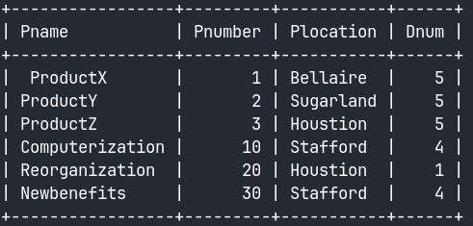

1. create table DEPENDENT

(Essn int not null, Dependent_name varchar(10) not null, Sex char(1) not null, Bdate date not null, Relationship varchar(2) not null);

insert into DEPENDENT values

(333445555,'Alice','F','1986-04-05','Daughter'),

(333445555,'Theodore','M','1983-10-25','Spouse'),

(333445555,'Joy','F','1958-0503','Spouse'),

(987654321,'Abner','M','1942-02-28','Spouse'),

(123456789,'Micheal','M',1988-01-04','Son'),

(123456789,'Alice','F','1988-12-30','Daughter'),

(123456789,'Elizabeth','F','1967-0505','Spouse');

